**ELASTIC LOAD BALANCER**

**Resource Quota :**

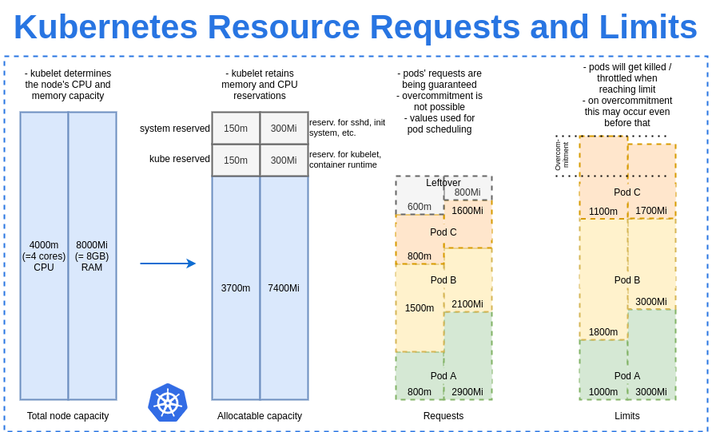

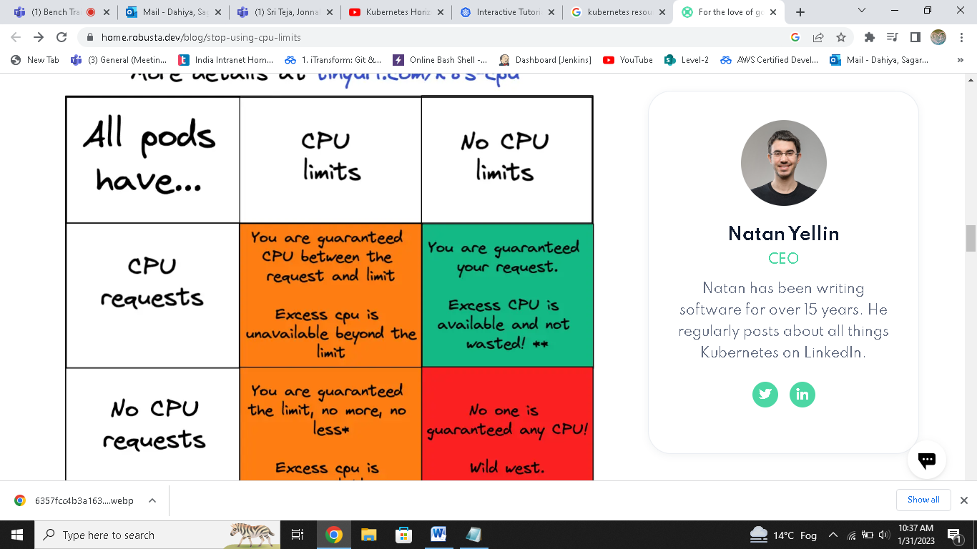

**apiVersion: v1**

**kind: Pod**

**metadata:**

**name: default-cpu**

**spec:**

**containers:**

**- name: default-cpu**

**image: nginx**

**resources:**

**limits:**

**cpu: "1"**

**#only limit defined,so request=limit**

**save it with demo.yml**

**kubectl apply –f demo.yml**

**kubectl describe pod podname**

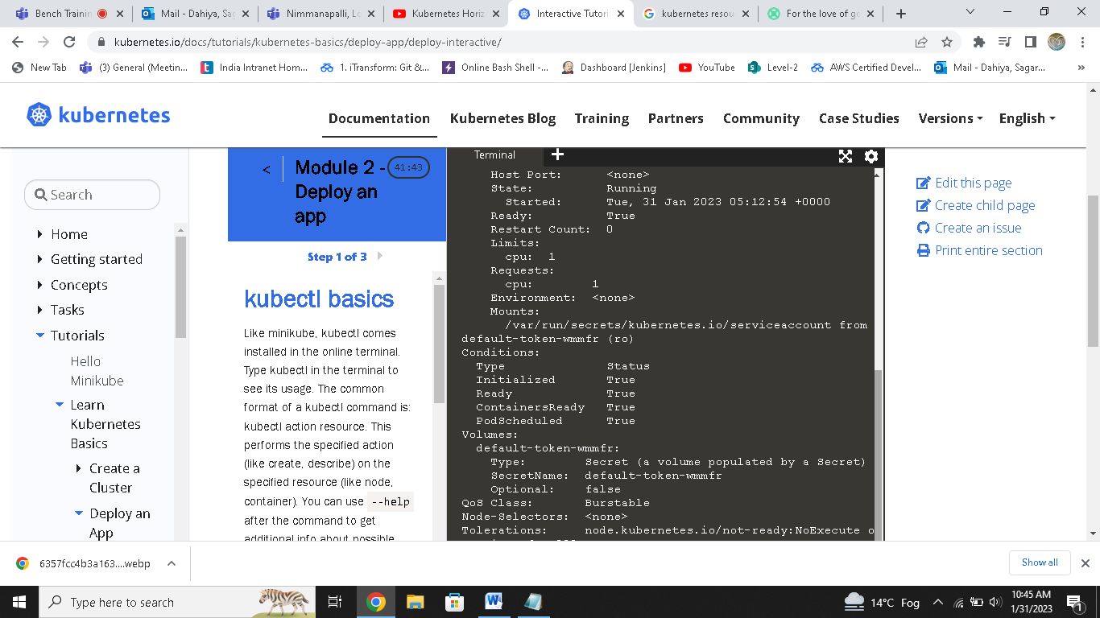

**apiVersion: v1**

**kind: Pod**

**metadata:**

**name: default-cpu-demo-1**

**spec:**

**containers:**

**- name: default-cpu-demo-1**

**image: nginx**

**resources:**

**requests:**

**cpu: "0.75"**

**#only request defined,but limit not defined**

**#then it take default cpu limit i.e. 1**

**Then again kubectl apply –f cpu.yml**

**Kubectl describe pod podname**

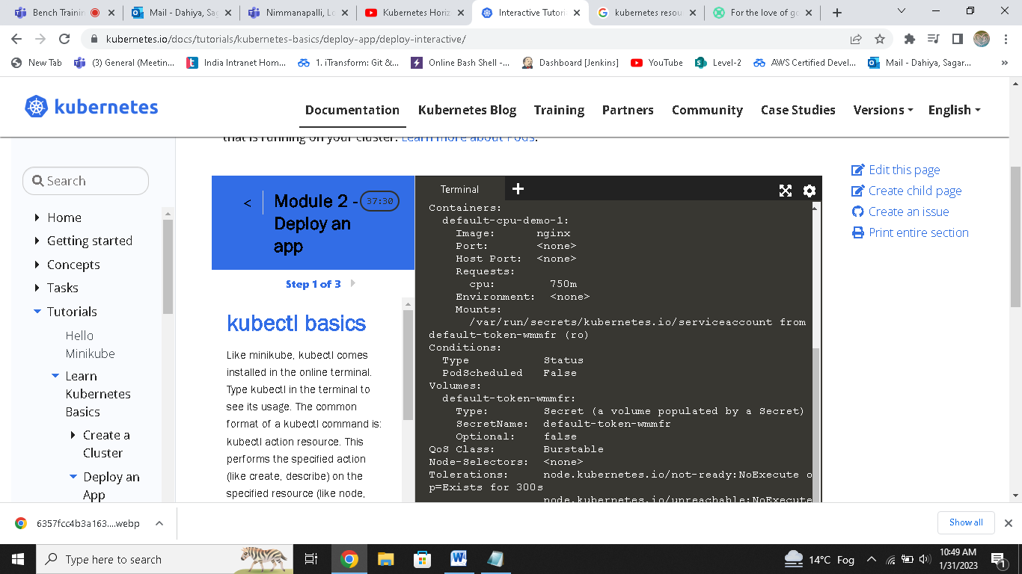

**Only request shown,so it take default limit**

**Now we check for memory**

**apiVersion: v1**

**kind: LimitRange**

**metadata:**

**name: mem-default**

**spec:**

**limits:**

**- max:**

**memory: 1Gi**

**min:**

**memory: 500Mi**

**type: Container**

**it will create a limitrange for memory**

**now create container**

**apiVersion: v1**

**kind: Pod**

**metadata:**

**name: constraints-mem-demo**

**spec:**

**containers:**

**- name: constraints-mem-demo-ctr**

**image: nginx**

**resources:**

**limits:**

**memory: "800Mi"**

**requests:**

**memory: "600Mi"**

**- If request is not specified & limit is given, then request = limit**

**Now run kubectl describe pod podname**

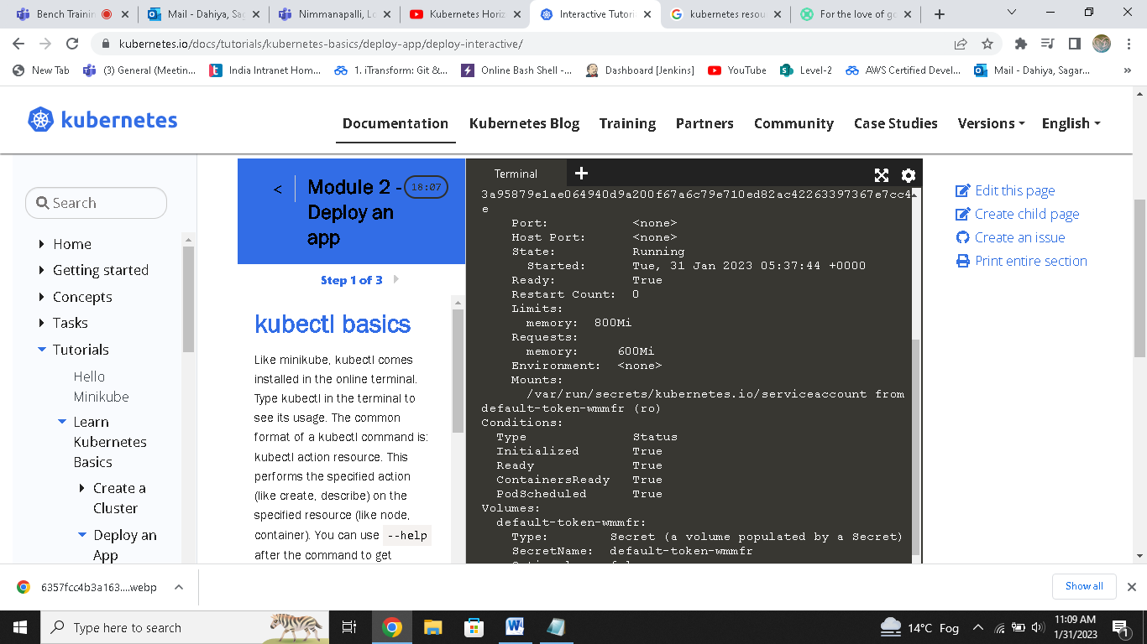

**But if we take limit 1200mb over 1gb limit set by limitrange,it will show error**

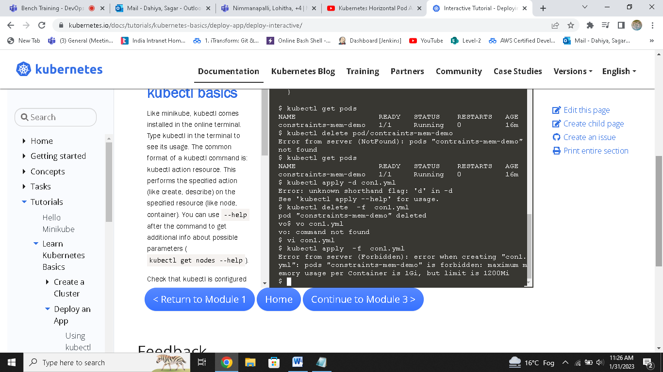

**You need to keep limit and request memory in range of limitrange else it give error.**